1. Display the first 10 elements of staff remembers ordered by their first name.

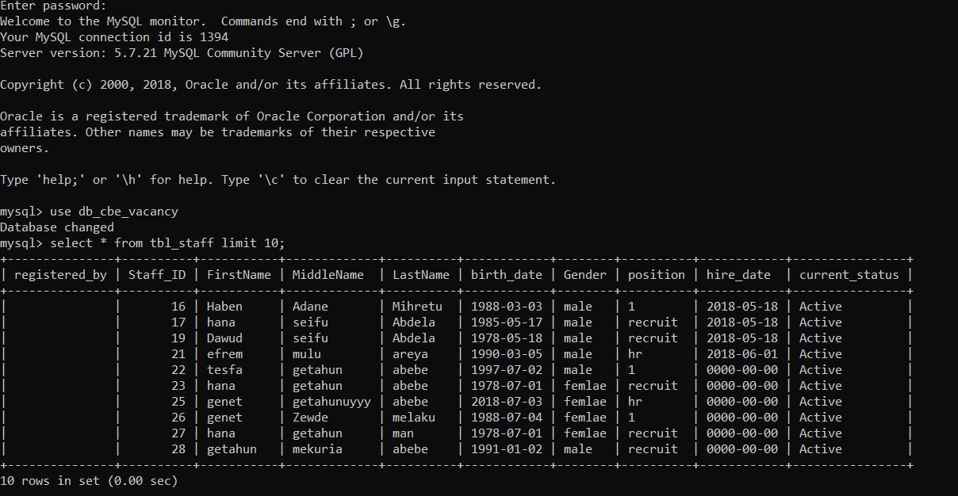

1. Display the first 2 staff remembers whose first name starts with G or their last name starts with m. Order this result by their first name in X order. Note that X either DESC or ASC.

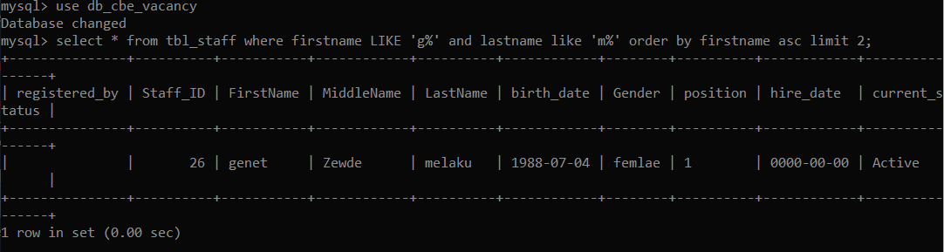

1. Display all staff member whose birth year is between 1988 and 2010.

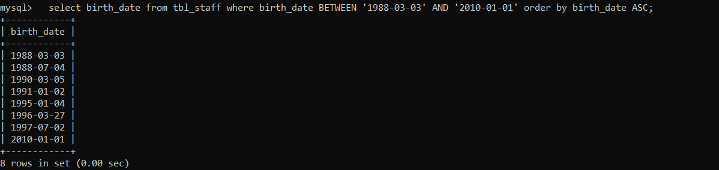

1. Count all the staff that have first name Hana.

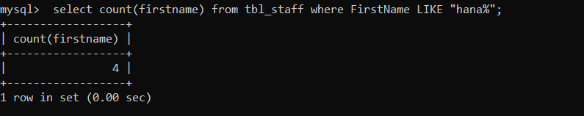

1. Staff member with an ID 25 has an error when he input his middle name. Remove number (887) from his middle name.

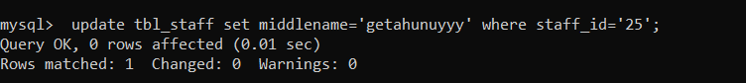

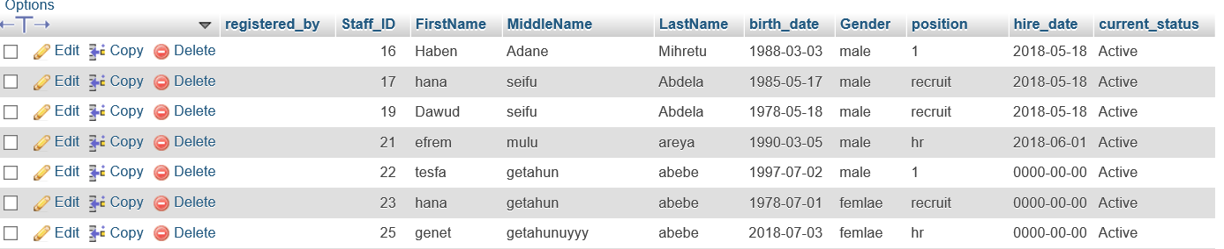

1. Add yourself as a new staff member.

C:\Users\LEMLI\Documents\SQL Question\Q6.PNG

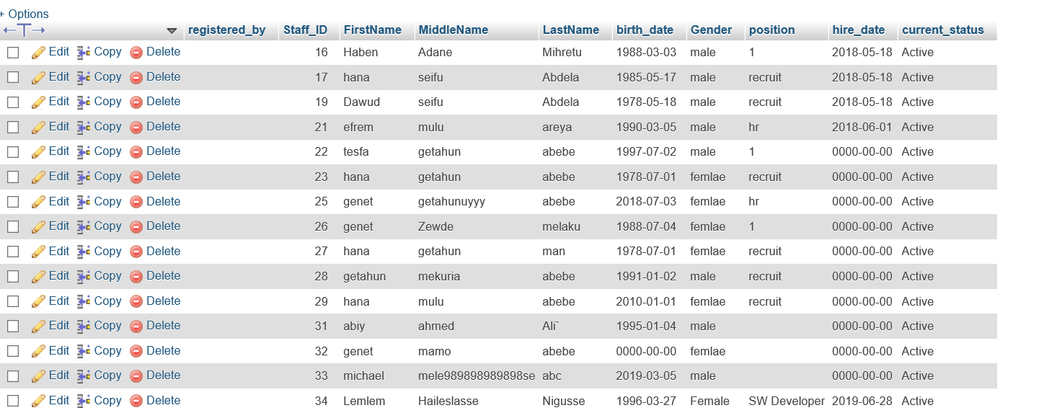

1. Join staff and user table on Staff_ID.

